Прайс-лист на кресла Chairman 08.07.2016 г.
Изображение | Наименование | Стоимость, руб.
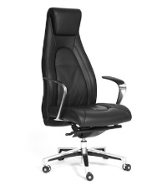 | CHAIRMAN FUGA | 36500
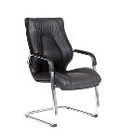 | CHAIRMAN FUGA V эко | 17857
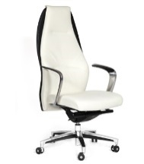 | CHAIRMAN BASIC | 41000
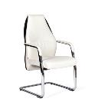 | CHAIRMAN BASIC V эко | 20743
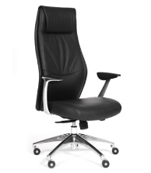 | CHAIRMAN VISTA экокожа | 22352
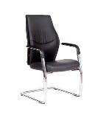 | CHAIRMAN VISTA V эко | 18077
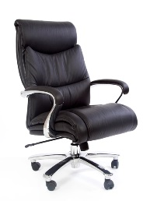 | CHAIRMAN 401 | 51200
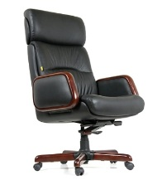 | CHAIRMAN 417 | 35880
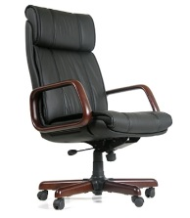 | CHAIRMAN 419 | 35282
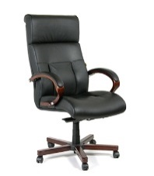 | CHAIRMAN 421 | 31460
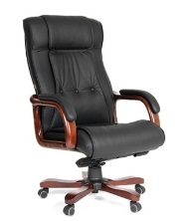 | CHAIRMAN 653 кожа | 28000
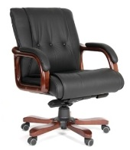 | CHAIRMAN 653 M кожа | 26598
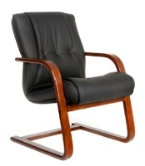 | CHAIRMAN 653 V кожа | 17316
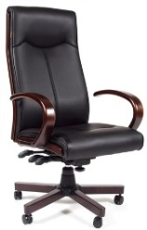 | CHAIRMAN 411 | 23500
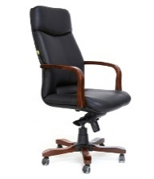 | CHAIRMAN 460 | 23500
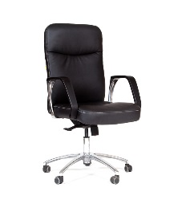 | CHAIRMAN 465 | 13923
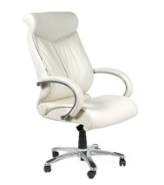 | CHAIRMAN 420 | 28717
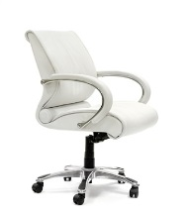 | CHAIRMAN 444 | 23615
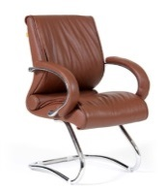 | CHAIRMAN 445 | 21983
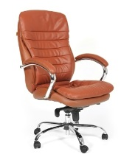 | CHAIRMAN 795 | 21000
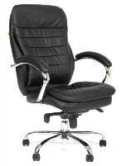 | CHAIRMAN 795 ЭКО | 17316
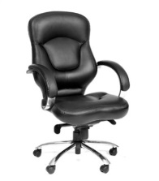 | CHAIRMAN 430 | 15400
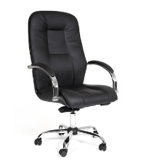 | CHAIRMAN 490 | 14976
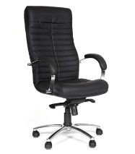 | CHAIRMAN 480 | 15000
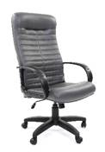 | CHAIRMAN 480 LT | 9315
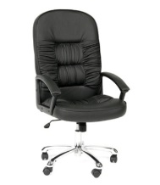 | CHAIRMAN 418 кожа | 14170
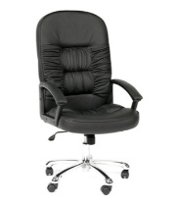 | CHAIRMAN 418 PU | 12578
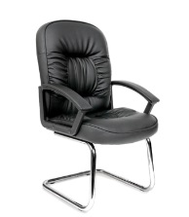 | CHAIRMAN 418 V | 11970
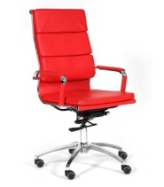 | CHAIRMAN 750 | 16000
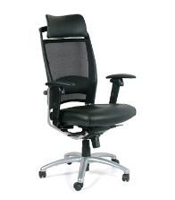 | CHAIRMAN 281А хром | 28782
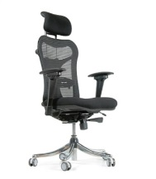 | CHAIRMAN 769 | 32760
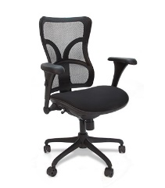 | CHAIRMAN 730 | 23888
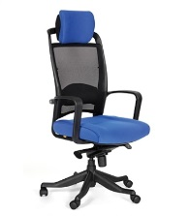 | CHAIRMAN 283 | 17550
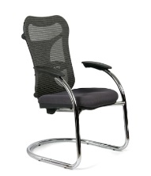 | CHAIRMAN 426 | 20774
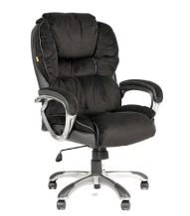 | CHAIRMAN 434 | 19000
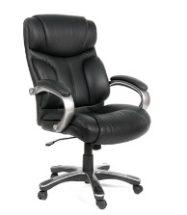 | CHAIRMAN 435 | 16910
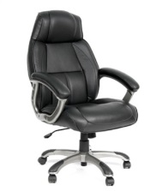 | CHAIRMAN 436 | 17557
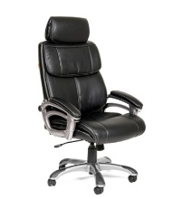 | CHAIRMAN 433 | 18200
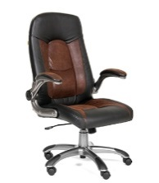 | CHAIRMAN 439 | 13400
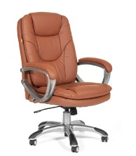 | CHAIRMAN 668 | 12800
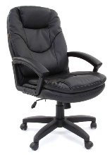 | CHAIRMAN 668 LT | 9263
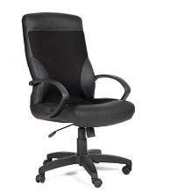 | CHAIRMAN 310 | 10490
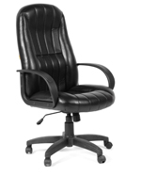 | CHAIRMAN 685 КЗ | 9840
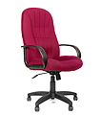 | CHAIRMAN 685 TW | 9998
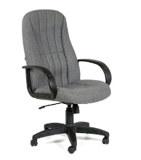 | CHAIRMAN 685 ст. | 8610
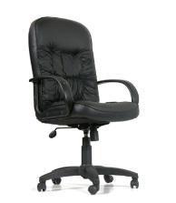 | CHAIRMAN 416 сплит К | 10800
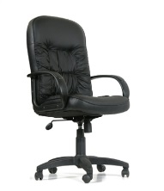 | CHAIRMAN 416 ЭКО | 8970
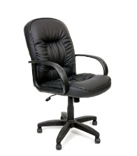 | CHAIRMAN 416 ЭКО М | 9315
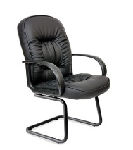 | CHAIRMAN 416 ЭКО V | 9045
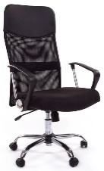 | CHAIRMAN 610 | 8603
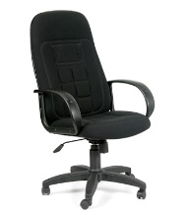 | CHAIRMAN 727 | 7549
 | CHAIRMAN 727 TW | 7823
 | CHAIRMAN 727 Terra | 7549
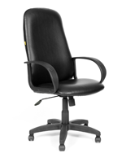 | CHAIRMAN 279 КЗ | 6248
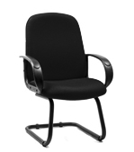 | CHAIRMAN 279V КЗ | 5985
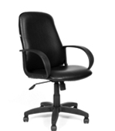 | CHAIRMAN 279M КЗ | 5993
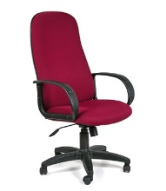 | CHAIRMAN 279 TW | 6630
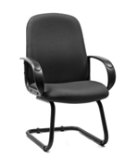 | CHAIRMAN 279V TW | 5942
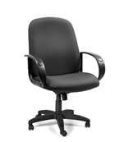 | CHAIRMAN 279M TW | 6197
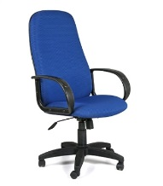 | CHAIRMAN 279 JP | 5550
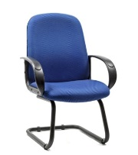 | CHAIRMAN 279V JP | 5643
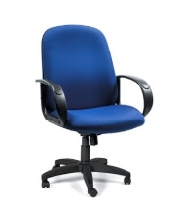 | CHAIRMAN 279M JP | 5610
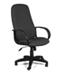 | CHAIRMAN 279 C | 5789
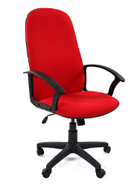 | CHAIRMAN 289 NEW | 5483
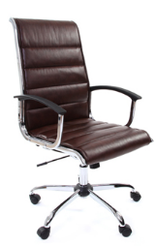 | CHAIRMAN 760 | 18200
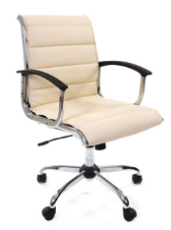 | CHAIRMAN 760 M | 17063
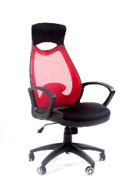 | CHAIRMAN 840 black | 14580
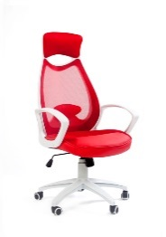 | CHAIRMAN 840 white | 13689
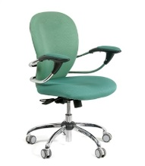 | CHAIRMAN 686 | 14365
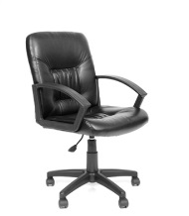 | CHAIRMAN 651 | 6983
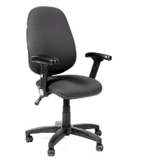 | CHAIRMAN АНТЕЙ JP | 9690
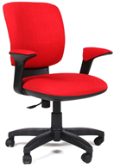 | CHAIRMAN 810 | 11880
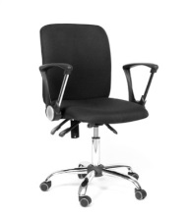 | CHAIRMAN 9801 хром | 7395
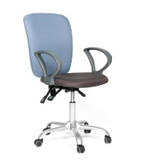 | CHAIRMAN 9801 | 7140
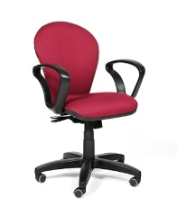 | CHAIRMAN 684 New TW | 6120
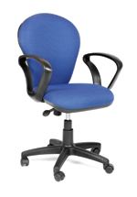 | CHAIRMAN 684 New JP | 5865
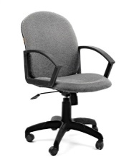 | CHAIRMAN 681 | 4973
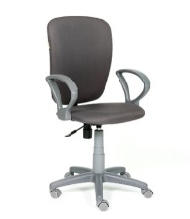 | CHAIRMAN 9801 PL | 5355
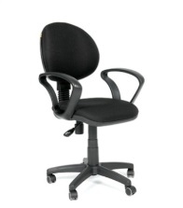 | CHAIRMAN 682 | 5100
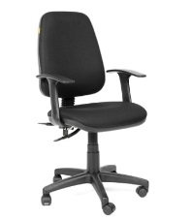 | CHAIRMAN 661 | 5088
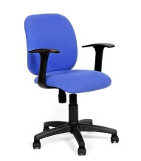 | CHAIRMAN 670 | 4920
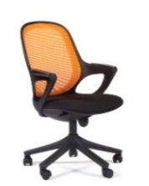 | CHAIRMAN 820 black | 12750
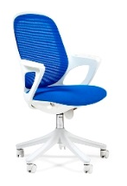 | CHAIRMAN 820 white | 14025
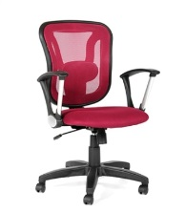 | CHAIRMAN 452 TG | 10455
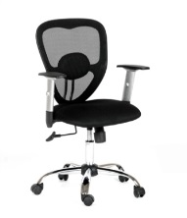 | CHAIRMAN 451 | 10328
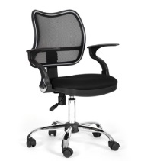 | CHAIRMAN 450 хром | 6435
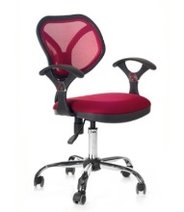 | CHAIRMAN 380 | 6375
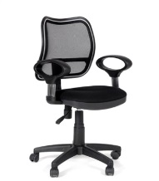 | CHAIRMAN 450 | 5813
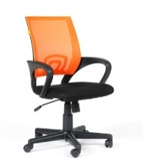 | CHAIRMAN 696 | 5610
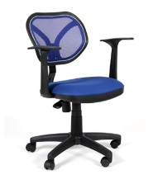 | CHAIRMAN 450 NEW | 4988
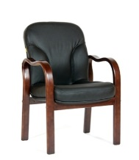 | CHAIRMAN 658 | 13462
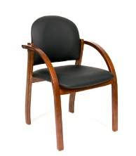 | CHAIRMAN 659 PU | 8820
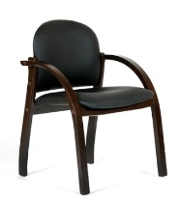 | CHAIRMAN 659 Terra | 6304
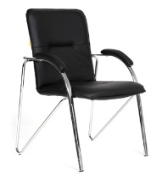 | CHAIRMAN 850 | 5550

Менеджер отдела продаж офисной мебели
Никитина Ирина
Тел.: 20-10-80, сот. тел.: 8-921-836-28-05
e-mail: mebel@galaktika35.ru

